Amazon SQS Demo (Individual)

Use Case
A shopping application stores orders in a queue until workers process them.

Steps
- Open Amazon SQS
- Create Queue
  - Type: Standard
  - Name: orders-queue
- Send Message
{
"orderId": 1001,
"customer": "John",
"amount": 500
}
- Click Send Message
- Click Send and Receive Messages
- Poll for messages
You will see the message in the queue.

Demo Explanation
- Producer sends message
- SQS stores message
- Consumer retrieves message later
- Producer and consumer do not need to be online at the same time

Interview Question
Why use SQS?
To decouple applications and handle traffic spikes reliably.

Amazon SNS Demo (Individual)

Use Case
Send notifications to multiple subscribers simultaneously.

Steps
- Open Amazon SNS
- Create Topic
  - Type: Standard
  - Name: alerts-topic
- Create Subscription
  - Protocol: Email
  - Endpoint: Your email address
- Confirm subscription from your email inbox.
- Open Topic → Publish Message
Subject:
Server Alert
Message:
CPU Utilization exceeded 80%
- Click Publish

Result
Email arrives instantly to all subscribers.

Demo Explanation
- Publisher sends one message
- SNS fans out the message
- All subscribers receive a copy

Interview Question
Why use SNS?
To broadcast notifications to multiple recipients simultaneously.

Key Difference Demo
SQS | SNS
Message Queue | Notification Service
Pull Model | Push Model
One consumer processes message | Many subscribers receive message
Stores messages | Does not store long-term messages
Decoupling applications | Broadcasting events

Easy Way to Explain
SQS = Parcel Box
- Message waits until someone picks it up.
SNS = Loudspeaker
- Announcement is broadcast to everyone listening.

Real-Time Amazon SQS Use Cases

1. Order Processing (Most Common)
Scenario:
An e-commerce website receives 10,000 orders during a sale.
Without SQS
- Application directly updates inventory, payment, shipping.
- Traffic spike can crash the application.
With SQS
Website → SQS Queue → Order Processors
- Orders are stored safely in the queue.
- Workers process them one by one.
- No orders are lost.

2. Image/Video Processing
Scenario:
Users upload photos.
Upload App → SQS → Image Processing Lambda
Tasks:
- Resize image
- Create thumbnails
- Add watermark
The upload finishes immediately while processing happens in the background.

3. Email Sending
Scenario:
100,000 users register during an event.
Application → SQS → Email Service
Instead of sending emails directly, requests are queued and processed gradually.

4. Log Processing
Scenario:
Applications generate millions of logs.
Application → SQS → Log Processor → Database/S3
Prevents log spikes from overwhelming storage systems.

5. Payment Processing
Scenario:
A payment gateway receives transactions.
Checkout → SQS → Payment Worker
If the payment system is temporarily busy, transactions wait safely in the queue.

6. Inventory Updates
Scenario:
A customer buys a product.
Order Service → SQS → Inventory Service
Inventory updates happen asynchronously without slowing down order placement.

7. Microservices Communication
Scenario:
Multiple services need to exchange data.
User Service → SQS → Notification Service
If Notification Service goes down, messages remain in the queue until it recovers.

8. Batch Processing
Scenario:
Generate monthly reports for thousands of customers.
Scheduler → SQS → Report Workers
Workers process reports in parallel.

9. IoT Data Collection
Scenario:
Thousands of sensors send temperature readings.
IoT Devices → SQS → Analytics System
SQS absorbs traffic spikes and prevents data loss.

10. Ticket Booking System
Scenario:
Movie tickets open for booking at 10 AM.
Users → SQS → Booking Service
Requests are processed in order, avoiding database overload.

Interview Scenario Question
Q: Why would you use SQS between an application and a database?
Answer:
To decouple components and handle traffic spikes. If the database becomes slow or unavailable, messages remain in the queue and can be processed later, preventing data loss.

Services Often Used with SQS
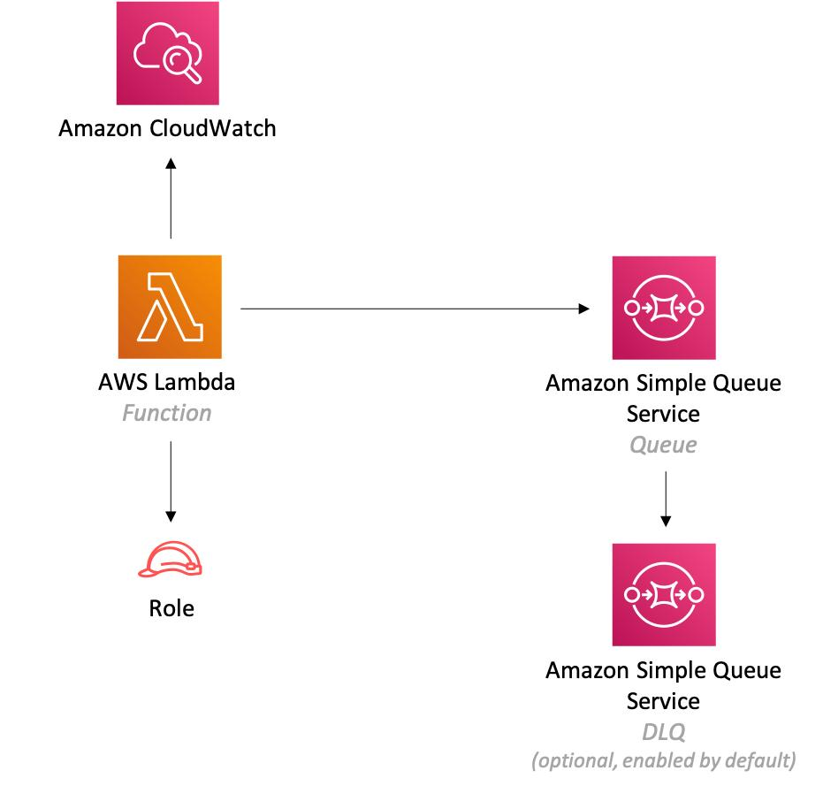
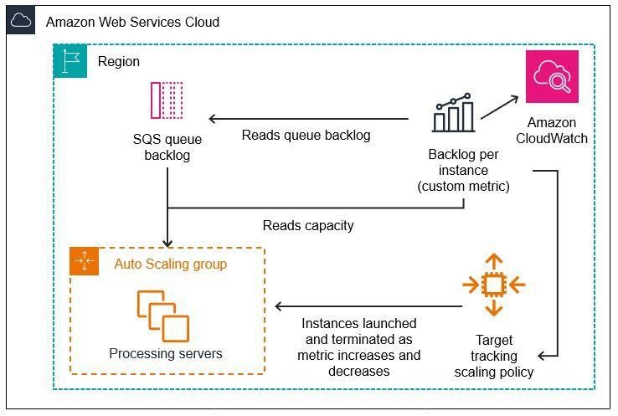
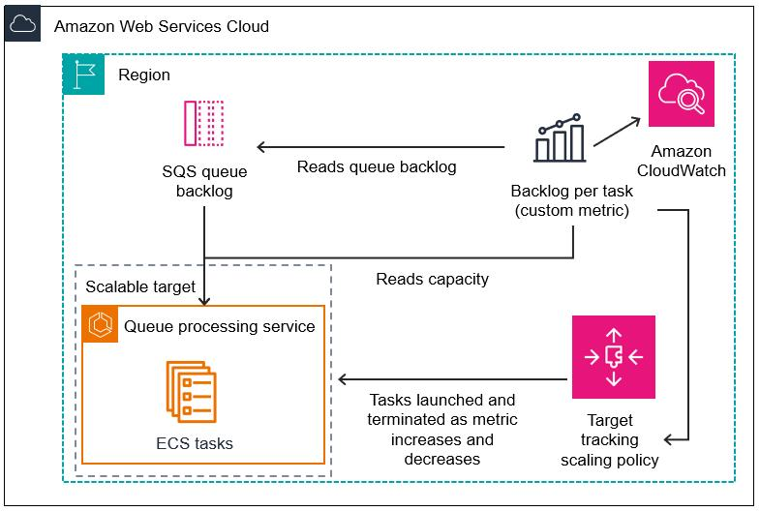
5
- AWS Lambda
- Amazon EC2
- Amazon ECS
- AWS Step Functions

One-Line Summary
Amazon SQS is used whenever you need to buffer requests, decouple systems, and process workloads reliably even during traffic spikes or temporary service failures.

